35_marea_lane_miles.csv
May 27, 2026
Definition of the Input File
VisionEval (https://visioneval.github.io/docs/model-inputs.html) explains that this file contains the number of freeway lane miles and arterial lane miles. In this dataset, these are shown at the Azone (city or county) level which the user may then combine into a single m_area. VisionEval explains that these are based on functional classification: roads will be classified as freeways/expressways, arterials, or some other source. (The VisionEval definition is at https://visioneval.github.io/docs/model-inputs.html#verspm-marea_lane_miles.csv.)
For example, in the table below, Albemarle County has 124.8 freeway lane miles and 384.3 arterial lane miles, both for the base year and the forecast year.
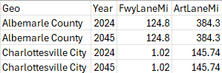
Note that unlike Azones or Bzones, there should be just a single Marea file when running VisionEval. In this particular case, it is appropriate to add the lane miles values.
Possible Scenario
The document Task 7.2 Simplified Scenario Development guide available at A Playbook for Simplified Approaches for Creating Scenarios in VisionEval mentions this input file in response to the following question: “Available transportation supply dictates what transportation options consumers will use when traveling. Inputs in VE supply modules answer the following: How do changes in freeway and arterial lane miles affect DVMT?” For this reason, a scenario may be developed that changes these lane miles from the base case.
There are at least two considerations when using this input to develop a scenario.
- One should consider what the 2045 base case should be. For instance, the input files herein used a base case of no construction, but perhaps a base case could be an increase in lane miles of some percentage (1%, 10%) or based on some forecast for future construction.

- As discussed in the methods section, for cities there may be some error in the base case estimates of lane miles. Thus individuals can replace these numbers with their own estimates.
Method Used for Virginia
Three main steps were used to estimate the lane miles for each city and county. Note that the assumption in step 3.5 will affect the quality of the results. As a check, the research team obtained a shapefile of roads for the City of Charlottesville (https://opendata.charlottesville.org/datasets/charlottesville::road-area/explore?location=38.032270%2C-78.459289%2C13&showTable=true) and computed the area of these roads (29.5 million square feet) and converted these to lane miles assuming 12-foot lanes (466 lane-miles). This 466 lane-miles would be all roads—not just interstates and arterials but secondary or urban roads that should not included in 35_marea_lane_miles.csv. The method used below for Virginia gives, for freeways and arterials, about 147 lane miles for Charlottesville. These calculations do not guarantee that the figure of 147 is accurate, but at least the figure seems reasonable in that it is of the right order of magnitude and smaller than the total lane miles for all Charlottesville roads.
- Source: Table 36. Transportation Sector Energy Use by Fuel Type within Mode, U.S. Energy Information Administration
  - URL: https://www.vdot.virginia.gov/about/our-system/highways/mileage-tables/
  - Location: About–VDOT’s transportation system–Highways–Mileage tables
  - Search Keyword: Not Applicable
  - Related Sheet: Not Applicable

- Year that the Data Reflect: 2024 (Base Year), 2024 with Growth Rate between 2022 and 2024 (Target Year)
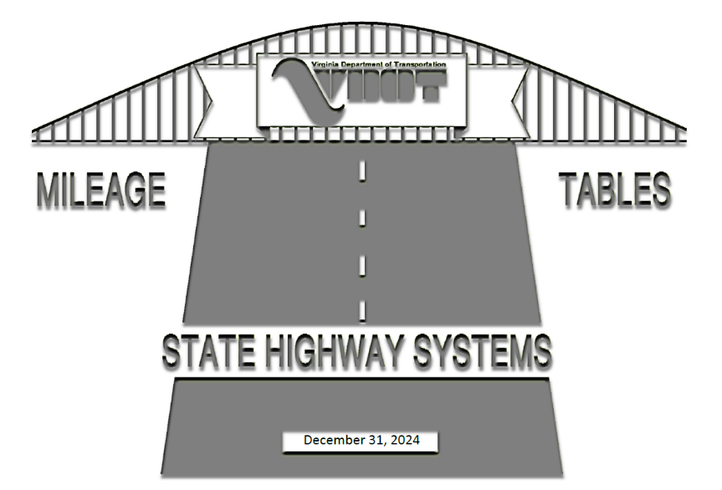

- How the Data Were Processed
  - Lane Mileage Data Mapping for Roads Maintained by VDOT: The data source provides lane mileage by district and county. To maintain consistency with VisionEval input requirements, the data was mapped as follows:
VisionEval | The data Source
Freeway | Interstate
Arterial | Primary

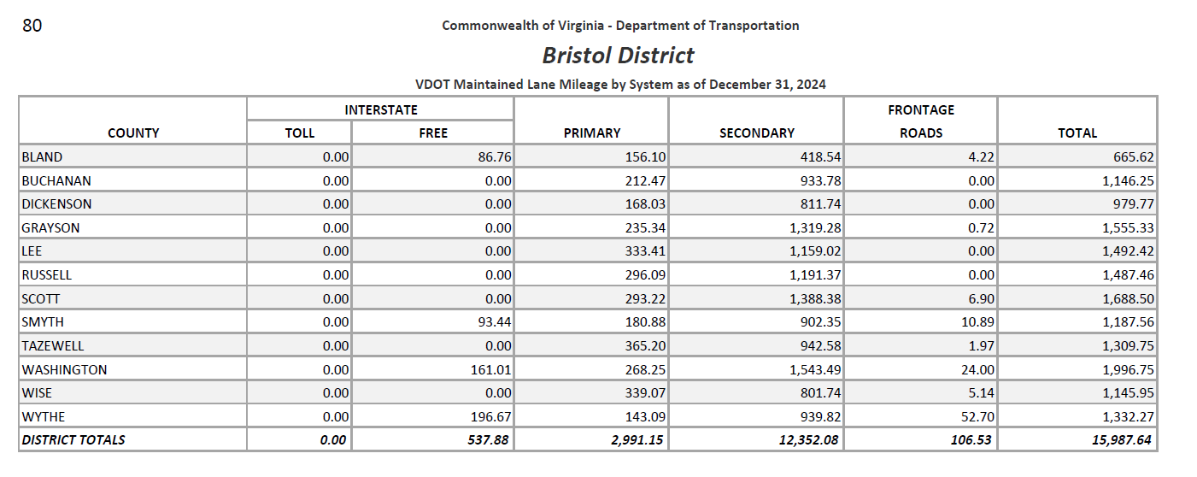
Note: To maintain consistency with VisionEval Geography, five counties (Elizabeth City Maintenance, Nansemond Maintenance, Norfolk Maintenance, Princess Anne Maintenance, and Warwick Maintenance) were Removed.

  - Lane Mileage Estimation for Cities: The data source does not provide lane mileage for cities, but only centerline mileage. For now, the number of lanes by city is set aside for later consideration in step 3.5, and the data was mapped as follows.
VisionEval | The data Source
Freeway | Total, Urban Interstate System Mileage by surface types
Arterial | Principal/Minor Arterial Roads, Urban System-Functional Class by Municipality

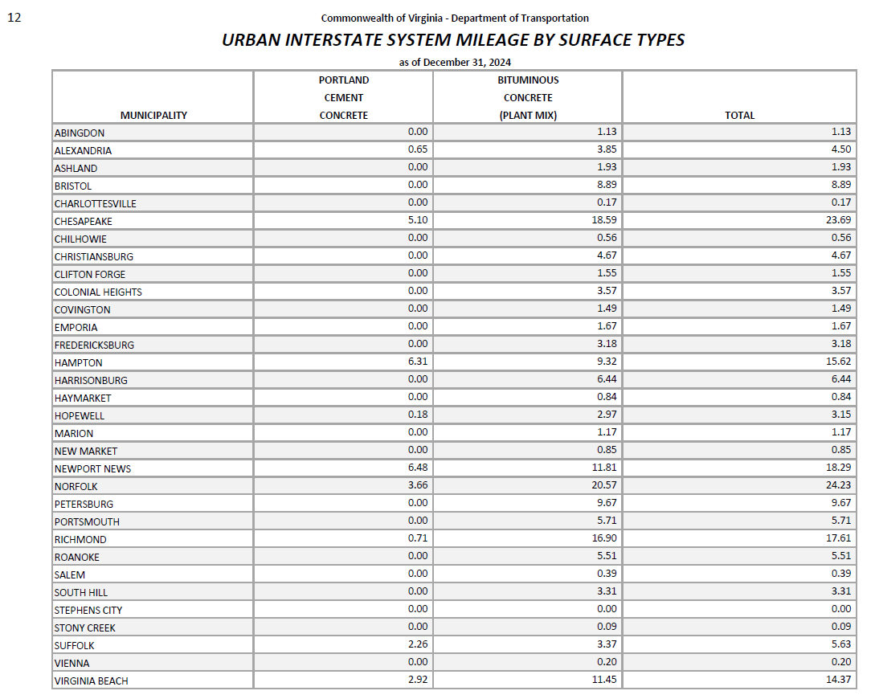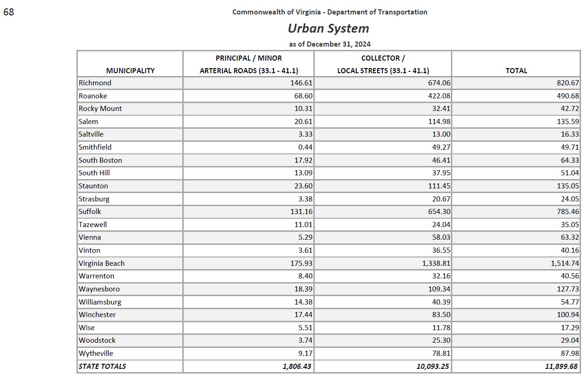
  - Growth Rates Projection: The growth values were projected using the compound annual growth rate (CAGR) calculated from 2022 to 2024. Negative CAGR values were replaced with 0%, and abnormally high values exceeding 1% were capped at 1%. (The reason 1% was chosen was that this was the average CAGR for the 133 cities and counties and thus values above 1% were believed to be higher than expected.) 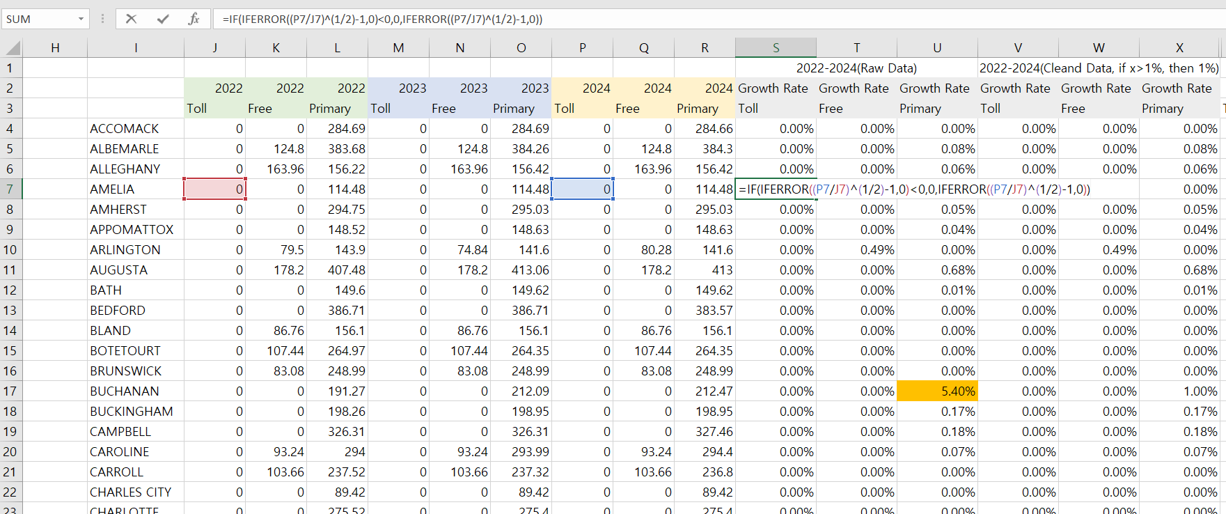 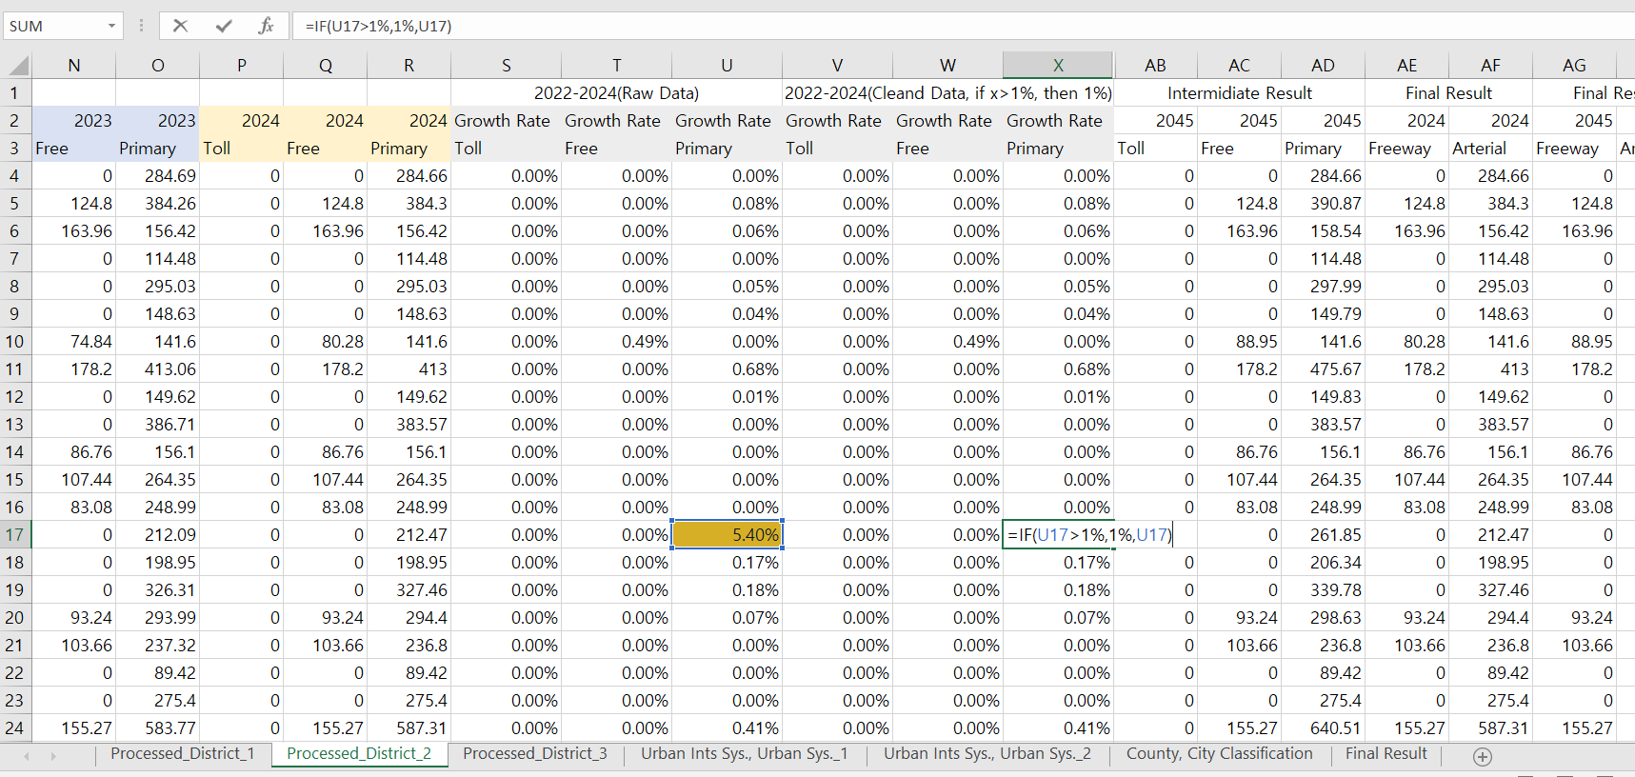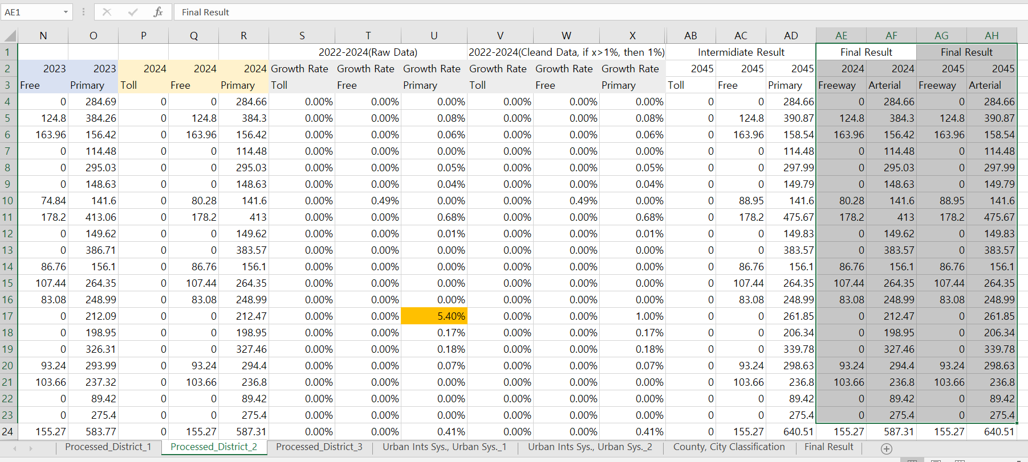

  - One possibility would be to do a target year value projection, where the 2045 target-year values could be projected using the compound annual growth rate (CAGR) calculated in Section 3.3. However, for longer term calculations (e.g., 2024 to 2045) this may not be defensible, thus for now, 2045 values have been set to be equal to those for 2024.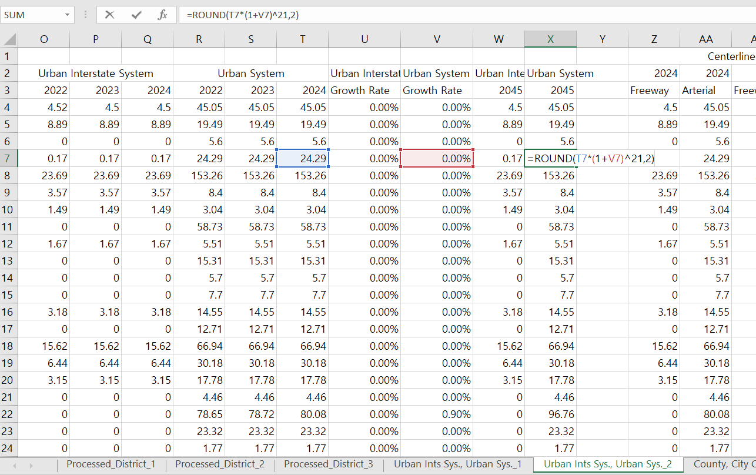
  - Conversion to Lane Mileage for the urban system: To convert centerline mileage to lane mileage in step 3.2, the number of lanes was assumed to be six for the urban system. This assumption may need to be refined in future updates. This assumption does not affect the calcuations of VDOT-maintained interstate and primary mileage shown in step 3.1.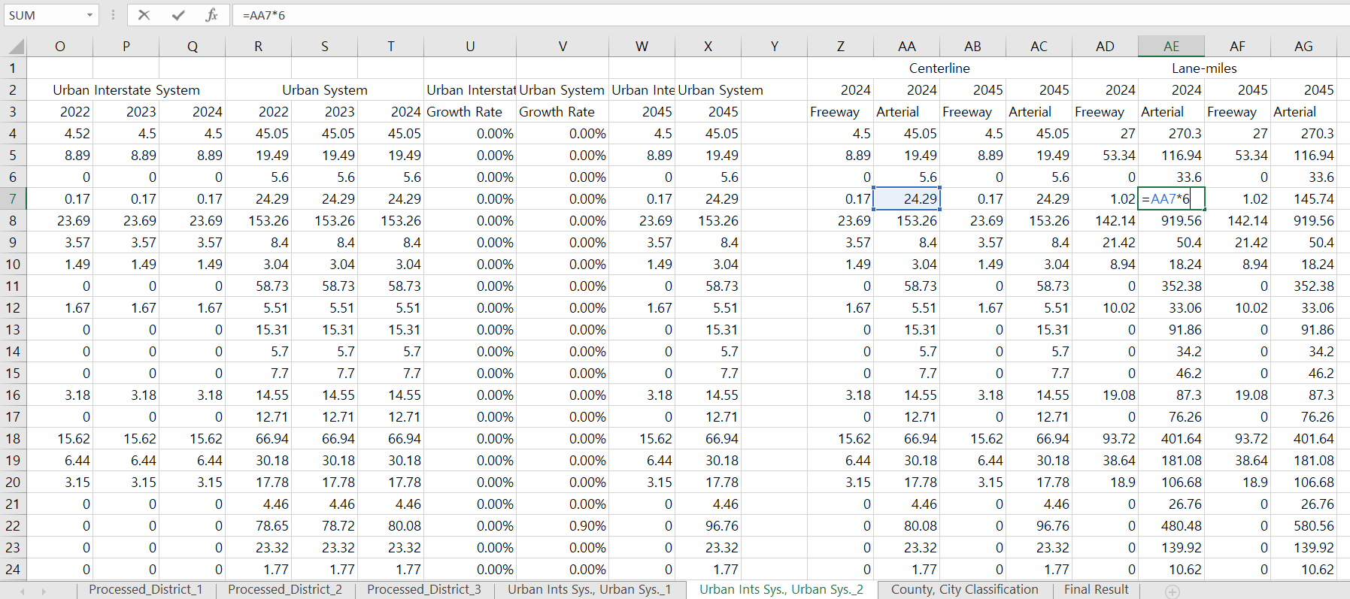

  - Final Result
